# Abstract

With highly developed information technology, people have become accustomed to using virtual keyboards to type and text in various situations. In many scenarios, people need to type with only one hand and use the other hand to do other things. Nonetheless, mobile device keyboards still lack comprehensive support for one-handed typing, potentially leading to accidental touch and missed touch, which hinders typing efficiency. Our goal is to better understand the user experience of one-handed typing and to explore ways to improve the effectiveness and efficiency of typing on mobile devices with one hand. In this article, we provide a detailed description of our study along with our initial design for one-handed typing. We employed a detailed survey and conducted contextual inquiries to study the potential difficulties and motivation of one-handed typing on mobile devices and developed 6 user requirements. We then established a paper prototype that contains key features such as adjusted key width, and revised punctuation keyboard. Afterward, we evaluated our paper prototype via simplified user testing and heuristic evaluation and evaluated the results against our user requirements. The results show that our design fails to reduce recognition load. Based on the feedback, we implemented our design into a high-fidelity prototype and evaluated it with 15 participants. The statistical analysis shows that our design decreases the typing time when using our design keyboard, in comparison to the baseline design. The conclusion from this work paves the way for developing one-handed typing support features to increase typing efficiency.

# Introduction

(same as previous)

Based on the evaluation part we conducted in the previous section, we decided to improve our prototype and make a high-fidelity prototype. We first revised the original design functionality with user requirement 5, then we utilized Figma to build our high-fidelity prototype. One of the obstacles was to implement the interaction in Figma so we had to pay attention to every detail. After building our high-fidelity prototype, we evaluated it with 15 participants by conducting several tasks and collecting the completion time for each task. The difficulty was setting proper measurement metrics for those quantitative data. We incorporated hypothesis testing and the Wilcoxon test to do the data analysis, and the result showed that our keyboard design decreased the typing time compared to the original keyboard. In short, we created the high-fidelity prototype and did statistical analysis to evaluate our design in a quantitative way. The details are in sections 8 and 9.

# Related Work

(same as previous)

# User Requirements

User Requirement 5: User should be able to locate and enter emojis, punctuations, and numbers on the mobile device with one hand faster than their default (i.e., current or existing) one-handed method of entry (U05-15, U05-16, U05-17, U05-37, U04-09, U04-18, U02-08, U03-06, U03-18, U03-19).

There appears to be a breakdown in entering non-letters with one hand, such as emojis (U05-15, U05-16, U05-17, U04-09, U04-18), punctuations, and numbers (U02-08, U03-06, U03-18, U03-19, U05-37). To enter these characters, the user had to first switch the keyboard (e.g., switching from the default letters keyboard to the emojis keyboard) by locating and pressing the keyboard-switch key, with which the user struggled, since this key is located at the edge of the keyboard (U05-15, U05-37, U03-18, U03-19). Then, the user had to find the desired characters on the new keyboard, which was also hard to do: For example, to select the desired emoji, the user had to consciously look at the keyboard rather than relying on muscle memory because the emojis keyboard has way more keys (i.e., emojis to choose from) compared to the

letters keyboard and it also dynamically changes based on the frequently used emoji of the user (U05-16). A similar experience applies to the punctuations and numbers keyboard (U03-18, U05-37). Furthermore, because the user had to frequently enter these characters, almost in every message they sent, this process drastically slowed down the overall text entry speed (U05-17) and the user eventually stopped entering these characters due to its complexity (U05-37).

We selected this user requirement to evaluate our functional, high-fidelity prototype against because this is one of the two user requirements (with the other one being User Requirement 1) that could only be tested by quantitative user evaluations, which is the focus of the current assignment. Specifically, testing this requirement requires a study that manipulates keyboard design (our design vs. existing design) as the independent variable and measures typing speed as the dependent variable, then compares the mean typing speed on each keyboard design using statistical tests to determine the statistical significance and effect size. If the resulting

difference showed our design with significantly faster typing speed than the existing design, then we would consider our prototype to meet this requirement. Thus, User Requirement 5 was selected for this assignment.

# Final Design & Functional High-Fidelity Prototype

Before we built our high-fidelity prototype in Figma. We first had to identify which features of our design we needed to implement in order to evaluate the user requirement we selected. This is because a prototype should just be implementing some, rather than all features of a design, and a prototype with high-fidelity just means those implemented features have to be actually functional. Then, using those functional features should allow us to evaluate our design prototype against the user requirements, achieving the goal of the user study. Therefore, picking the right features to implement was very important. To do so, we had to think ahead a bit by considering the study design, specifically, the tasks which we would ask the participants to perform on our prototype (see Tasks and Procedures section for more info); we designed and created the high-fidelity prototype in Figma with all the functional features that allow the user to execute those tasks.

Based on the feedback we discovered from the qualitative user evaluation, we realized that our biggest issue with our low-fidelity prototype was the discoverability of the features, e.g., how to switch from the current keyboard to our new shifted keyboard, how to enter the alternative values of the punctuation keys, etc. Thus, to improve this, for each feature we implemented in the high-fidelity prototype, we also built a corresponding popover tutorial describing how to interact with them that would appear upon first opening the prototype in Figma. As such, the user would be able to easily discover the features and be able to use them effectively during the testing.

In the remainder of this section, we discuss the implemented features in detail and their corresponding interactions, along with screenshots of those features in our prototype.

## **Frame 1**

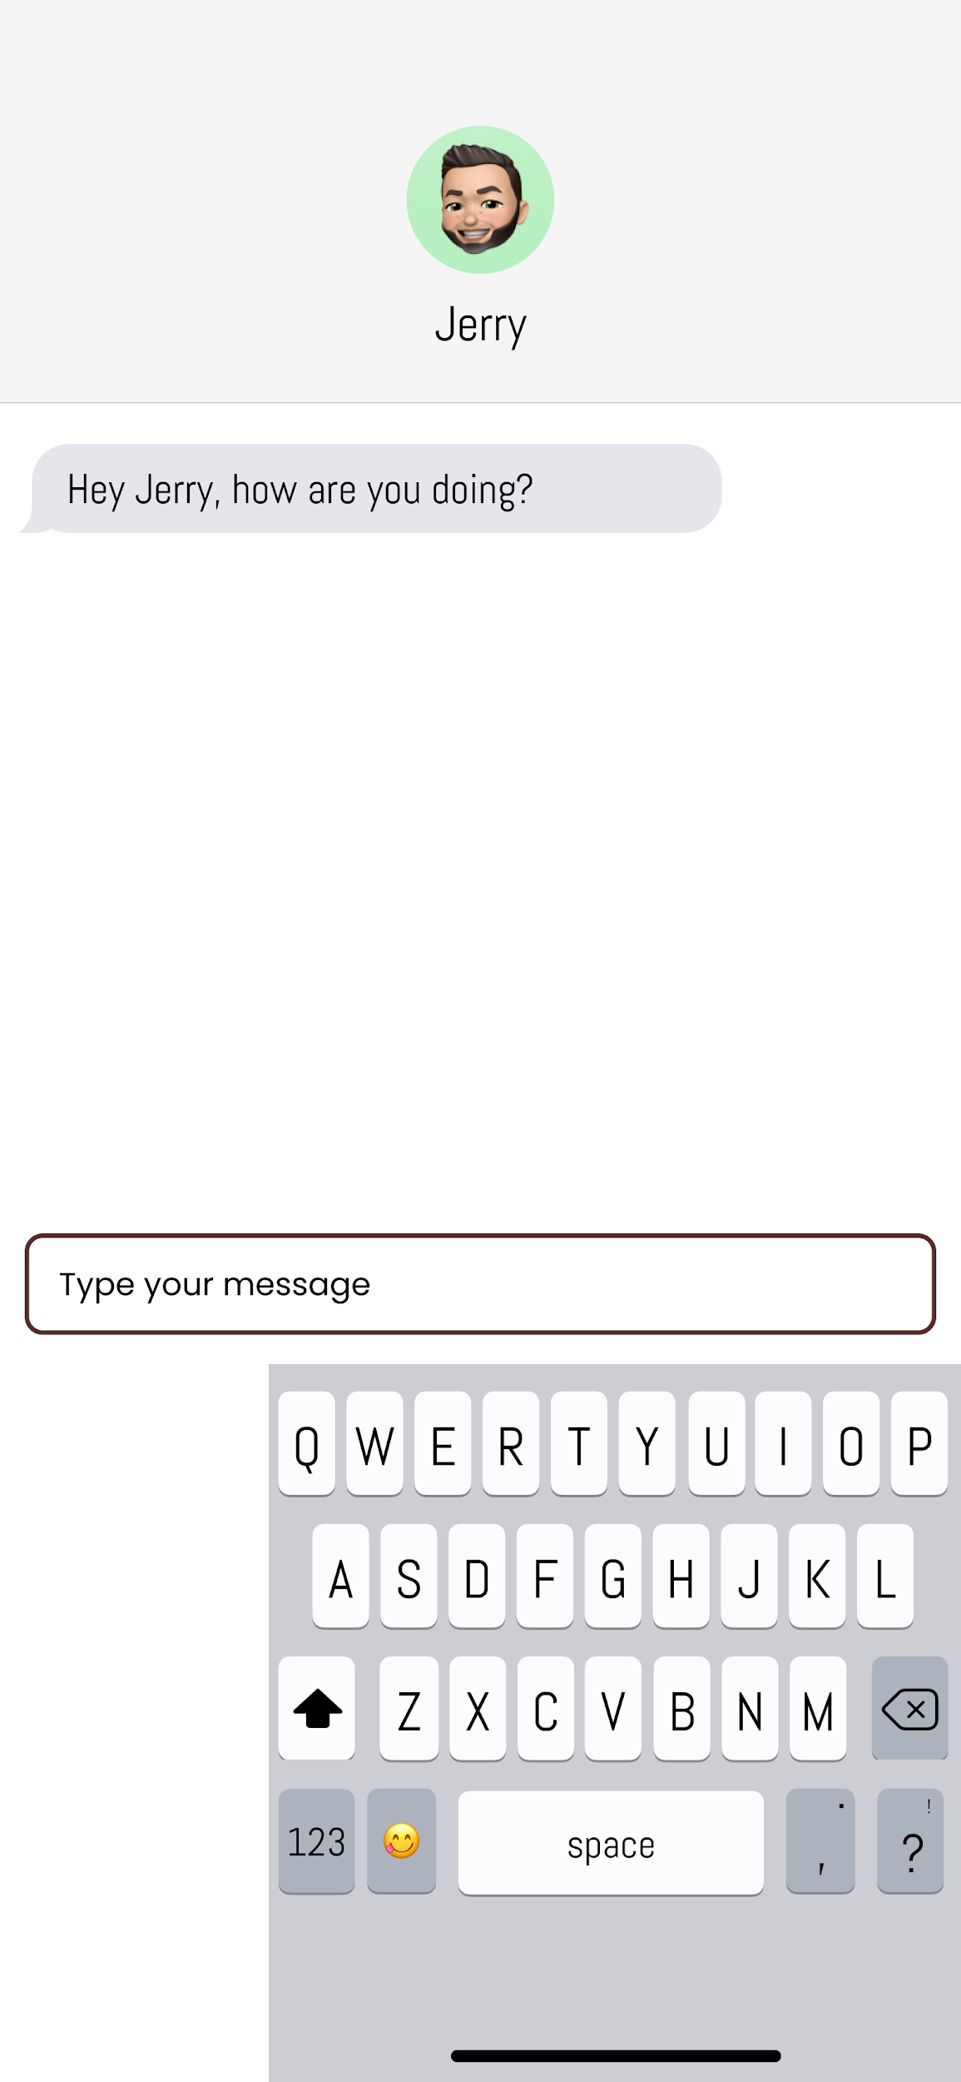

This first screenshot shows the first frame (the one-handed letters keyboard) of our prototype created in Figma. All features on this frame are listed below.

* All of 26 letter keys on the keyboard
  + Pressing on a letter key will enter the corresponding letter in the textbox above the keyboard
  + Currently, all letters are in upper-case
* Delete key
  + Pressing on the delete key will delete *everything* the user has entered
* Space key
  + Pressing on the space key will enter a space in the textbox
  + Holding down on the space key and then sliding left will switch the keyboard from this design (i.e. our one-handed keyboard design) to the current/existing keyboard design
* 2 Punctuation keys (at the bottom right)
  + Pressing on these two keys will enter “,” and “?” respectively
  + Holding down on these two keys and then sliding up (or in any direction) will enter “.” and “!” respectively
* Emojis keyboard switch key (at the bottom left)
  + Pressing on this key will switch to the emojis keyboard (frame 2)
* Numbers keyboard switch key (at the bottom left)
  + Pressing on this key will switch to the numbers keyboard (frame 3)

## **Frame 2**

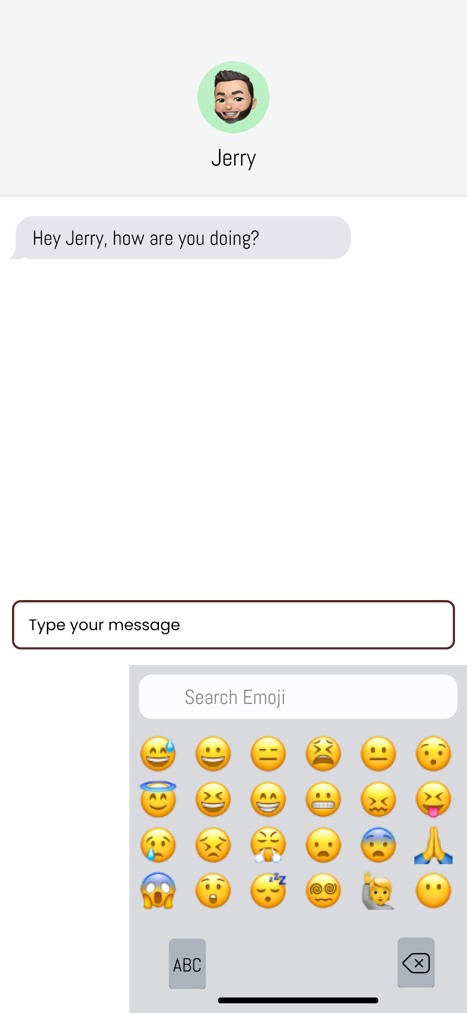

This screenshot shows the second frame (the one-handed emojis keyboard) of our prototype in Figma. The features on this frame are listed below.

* 4 emoji keys
  + Pressing on any of the following 4 emoji keys will enter the corresponding emoji in the textbox
    - 😐
    - 😆
    - 🙏
    - 😵‍
  + Remark: the reason why we only implemented these 4 emojis keys to be functional is because these are the only 4 emojis used in the tasks performed by the participants
* Letters keyboard switch key (bottom left)
  + Pressing on this key will switch back to the letters keyboard (frame 1)
* Delete key (bottom right)
  + Pressing on this key will delete everything the user has entered in the textbox

## **Frame 3**

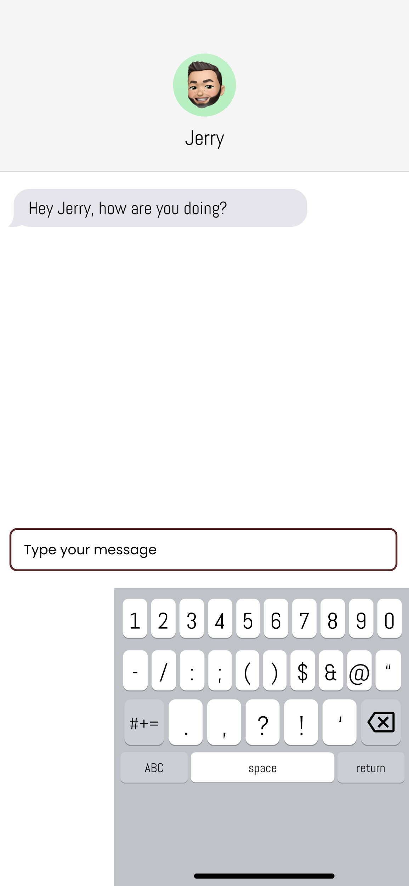

This screenshot shows the third frame (the one-handed numbers keyboard) of our prototype in Figma. The features on this frame are listed below.

* All 10 number keys (at the top of the keyboard)
  + Pressing on any number key will enter the corresponding number in the textbox
* 4 punctuation keys (third row of the keyboard)
  + Pressing on the 4 punctuation keys will enter the corresponding punctuation:
    - ,
    - .
    - ?
    - !
* Delete key
  + Pressing on this key will delete everything the user has entered in the textbox
* Letters keyboard switch key (bottom left)
  + Pressing on this key will switch back to the letters keyboard (frame 1)

## **Frame 4 (current/existing design corresponding to Frame 1)**

Our prototype also contains the following 3 frames, which imitate the current/existing keyboard design on an iPhone. These 3 frames have the same functionality as the previous frames respectively. The reason why we had to implement these 3 frames as well is because in our study, we needed to compare the typing speed on our design vs. on the existing/current design. But typing on Figma and typing on an actual phone may introduce confounds, since Figma has slight delays for each interaction, unlike a real final product of our keyboard.

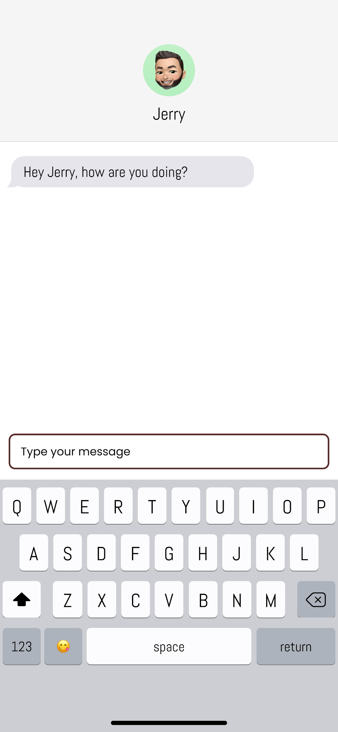

## **Frame 5 (current/existing design corresponding to Frame 2)**

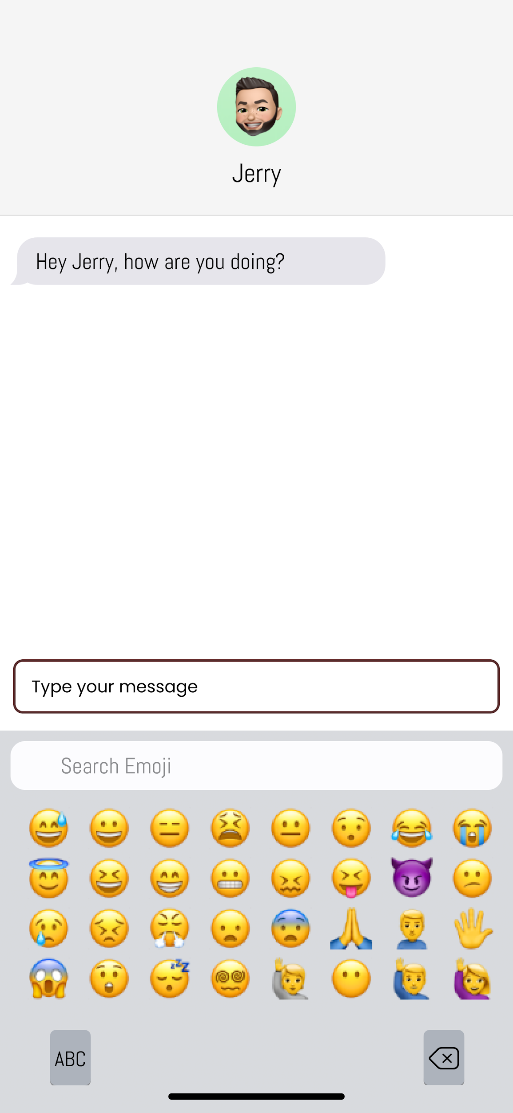

## **Frame 6 (current/existing design corresponding to Frame 3)**

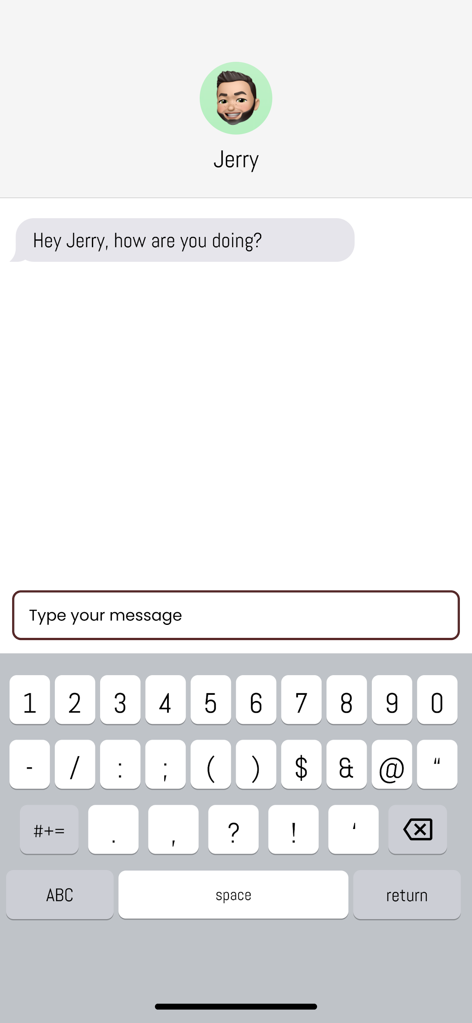

# Quantitative User Evaluation

To ensure the quality and consistency of our user testing, we first created the study protocol as a group, defining its purpose, method, tasks/procedures, which each team member closely followed when conducting the study individually. This section elaborates on the protocol, discussing it in detail while maintaining its core aspects, such that it accurately presents what each team member did to conduct the user testing.

## **Purpose**

The purpose of our study is to evaluate our new keyboard design against User Requirement 5, which we selected together. Specifically, we wanted to test whether entering punctuation, emojis, and numbers on our keyboard design with one hand is faster than entering them on the existing/current keyboard with one hand.

## **Method**

First, we picked a user goal for the study that closely reflects User Requirement 5: to enter punctuation, emojis, and numbers using the keyboard with one hand. Based on this, we designed our study to employ multiple typing sessions, and within each session, participants would be performing tasks involving typing texts with different punctuation, emojis, or numbers. The specific sessions and tasks are described in the Tasks/Procedures section.

Next, we carefully designed the details of the study method. There was 1 independent variable, being *keyboard design*, with two conditions: our new one-handed keyboard design (i.e. intervention, or experimental), and the current/existing keyboard design (i.e. baseline, or control). There were 3 dependent variables, *time to enter punctuation*, *time to enter emojis*, and *time to enter numbers* (matching the three constructs in User Requirement 5). The reason why we split the time into three dependent variables is because we wanted to separately analyze *keyboard design* x *punctuation time*, *keyboard design* x *emojis time*, and *keyboard design* x *numbers time*. This increased level of specificity allowed us to pick up any effects of keyboard design to determine whether our design at least partially met User Requirement 5.

We decided to employ a paired or within-subject design for our study, such that each participant would be exposed to both conditions of the independent variable, i.e. using both keyboard designs to enter the texts. The motivation for this was that we did not have enough time and resources to recruit a large sample of participants, thus making a within-subject design work better in this case. Because of the nature of a within-subject design, we attempted to counterbalance the effect of the order of the condition to which the participants were exposed, i.e. whether they first typed on the our keyboard design or on the existing keyboard design, by randomly selecting one of the two keyboards designs for each participant to use first.

Since our study was a paired design, and we wanted to separately analyze *keyboard design* x *punctuation time*, *keyboard design* x *emojis time*, and *keyboard design* x *numbers time*, where keyboard design, being the independent variable, only had *2* conditions, we decided to use 3 paired Wilcoxon tests, with one for each interaction, according to Koji Yatani’s table. Consequently, we defined the 3 null hypotheses, one for each test: For example, for the Wilcoxon test for the *keyboard design* x *punctuation time* interaction, the null hypothesis we defined is, there is *no significant difference* between the mean time to enter punctuation on the existing keyboard compared to our new keyboard when using one hand. We also defined 3 corresponding alternative hypotheses, one for each test: The alternative hypothesis for the same example is, the mean time to enter punctuation on our new keyboard is *significantly faster* than that of the existing keyboard, when using one hand.

After deciding on the statistical test, we used G*power to determine the minimum number of participants needed with parameters 0.8 for effect size, 0.05 for error probability (alpha), and 0.8 for power, which produced a minimum sample size of 12. Since we had 5 team members, each team member tried to recruit 3 participants, aiming for a total of 15. We also defined the inclusion/exclusion criteria for the participants, being 1) they must be at least 18 years old, 2) right-handed or primarily use their phone with the right hand, and 3) preferably use an iPhone (Note: the last criterion is preferred but not required).

With the protocol being completed, each team member then recruited 3 participants and conducted the user testing individually, while closely following the tasks/procedures described in the protocol (see next section). Afterwards, we collectively analyzed the timing results recorded by all team members by using the paired Wilcoxon tests to compute the statistical significance, to ultimately determine whether our keyboard design truly made entering punctuation, emojis, and numbers with one hand faster than the current design.

## **Tasks/Procedures**

This section elaborates on the tasks the participants performed during the study and the procedure in which the study was conducted.

The study consisted of 2 sessions:

1. Session 1, the practice session, where the goal was for participants to learn and adapt to the two Figma keyboards of the study, and the timing results did not count towards the statistical analysis later on, the results we recorded do not , and
2. Session 2, the analysis session, where the timing results count towards the statistical analysis

Both sessions follow the exact same format. Within each session, participants were exposed to both conditions of our independent variable, i.e. they used both the existing keyboard and our new keyboard to enter text with one hand (which keyboard they started on was randomly determined for each participant to counterbalance the order effect); specifically, there were 3 pieces of text which the participants had to enter (on each keyboard) with their right hand only, one for punctuation, one for emojis, and one for numbers. Each piece of text consisted of 4 strings concatenated together in *random order*; the 4 strings for each piece of text are listed below.

* Session 1
  + Punctuation
    - HELLO,
    - HELLO.
    - HELLO?
    - HELLO!
  + Emojis
    - WORLD😐
    - WORLD😆
    - WORLD🙏
    - WORLD😵‍
  + Numbers
    - BREAD37
    - BREAD42
    - BREAD10
    - BREAD96
* Session 2
  + Punctuation
    - HORSE,
    - HORSE.
    - HORSE?
    - HORSE!
  + Emojis
    - WHALE😐
    - WHALE😆
    - WHALE🙏
    - WHALE😵‍
  + Numbers
    - CRUMB37
    - CRUMB42
    - CRUMB10
    - CRUMB96

For instance, the piece of text for punctuation which participants had to enter on the existing keyboard design in session 1 could be “HELLO?HELLO,HELLO.HELLO!”, and it could be “HELLO.HELLO,HELLO!HELLO?” when they enter this on our keyboard design. The reason for why we randomized the order of the strings is because we want to prevent the effect of participants getting better from one design to the other, *within* one session. Concatenating the strings in a different order makes the piece of text appear somewhat novel to the participant when switching from one keyboard design to the other (within one session), but still keeping the actual content of the piece of text the same, so the comparison between timing results of one condition and the other using the paired t-test would still be valid. We also chose to switch the word part of the string *between* sessions to prevent the effect of participants getting better from Session 1 to Session 2. Since we did not plan to formally compare the timing results between sessions, having a different word would not affect the statistical tests.

To sum up, at the beginning of each session, each participant was first randomly given a keyboard (i.e. either the existing keyboard or our new keyboard) they would type on first. Then, the participant used this keyboard with just their right hand to enter one piece of text for punctuation, one piece of text for emojis, and one piece of text for numbers, with each piece of text consisting of 4 strings listed above concatenated in a random order. The participant entered these 3 pieces of text again on the other keyboard with their right hand; each piece of text they entered had the same 4 strings as before, but the order of the strings were re-randomized and re-concatenated. The same process was repeated for both sessions. The detailed procedure which each team member closely followed is listed below.

Sentences enclosed by quotation marks are what each team member said to the participant word for word. Those that are not in quotations are instructions for investigators on what exactly needed to be done.

1. Obtain consent
   * Explain the purpose of the study: “In this study, we are testing the effect of keyboard design on typing speed.”
   * Briefly explain the participant’s responsibilities: “You will be using two Figma keyboards, which you have to download on your phone, to enter a series of short texts with your right hand (thumb). Specifically, you will need to enter a total of 12 pieces of text and the time for each will be recorded.”
     + 12 = (1 for punctuation + 1 for emoji + 1 for number) * 2 (keyboards per session) * 2 (sessions)
   * “The participation of the study is completely voluntary and you may quit the study at any time. The data collected from the study would be completely anonymous and confidential. Should you choose to participate in this study, please respond with ‘yes’, or ‘no’ otherwise.”
2. If the participant agreed to participate, then proceed with the following procedure. If not, then terminate the study and thank the participant for their time.
3. First, ask the participant to download Figma on their phone and sign up.
4. Ask the participant to open the link to the prototype and experiment with the keyboard.
   * <https://www.figma.com/proto/H67CtXLBhiUwUZ64UMXx3i/593-Functional-Prototype?type=design&node-id=1-133&t=KAkYGVyiXmpU6eGJ-1&scaling=scale-down&page-id=0%3A1&starting-point-node-id=1%3A133&mode=design>
5. While they are experimenting with the keyboard, clearly explain to the participants **all of the features in our prototype**.
   * i.e. the different possible interactions on each frame described in the previous [Final Design & Functional High-Fidelity Prototype](https://docs.google.com/document/d/1P2J6Sd90CK4GkyECEZw1sNcmLDeHL4qOkFJKgTspEUY/edit#heading=h.svctrg5ao4eb) section.
6. After the participant is familiar with every feature of the prototype, explain the following instructions for the participants in detail.
   * “I (the investigator) will first assign you one of the two keyboards in Figma that you have to type on first.”
   * “Then, I will show you a piece of text and you have to type this text using the keyboard with *your right hand*.”
   * “Please type (i.e. press on) one character at a time; make sure the current character has been entered (i.e. shown on the screen) before typing the next character.”
   * “Please type at your normal speed *but try your best to* ***not make mistakes***. If you do make a mistake, we have to restart.”
   * Make sure the participant clearly understands the instructions.
7. For both sessions, follow the following instructions exactly.
   1. First, randomly pick one of the two keyboards for the participant to *start* on & clearly tell them which one.
      * Make sure the participant currently has that keyboard opened in Figma on their phone.
   2. Shuffle (randomly) the order of the 4 strings for punctuation, concatenate them into one string (i.e. piece of text), and show it to the participant (either on paper or on a laptop).
      * Make sure the piece of text is in a very large font so the participant can easily see.
        + e.g. hello,hello?hello!hello.
      * Ask participants to look at this piece of text and ask if they have any questions
   3. Start the timer as soon as the participant begins typing, and end the timer as soon as the participant finishes typing the last character in the text.
      * Record this time in the corresponding cell of the table.
   4. If the participant made a mistake, ask them to stop, give the participant a 60 seconds break, restart this test by repeating steps **ii** to **iii** (i.e. need to re-shuffle the order of the 4 strings).
   5. Repeat steps **ii**, **iii**, **iv** for emojis, and then numbers.
      * By the end of this step, the participant would have entered 3 pieces of texts and you would have recorded 3 different times.
   6. Repeat steps **ii**, **iii**, **iv**, **v** for the other keyboard.
      * By the end of this step, the participant would have entered 3 more pieces of texts, with now a total of 6 pieces of texts entered and 6 different times recorded (by you).
      * This ends the first session.
      * Take a 2 minute break.
   7. Repeat steps **ii**, **iii**, **iv**, **v**, **vi** for session 2.
      * Note: please use the strings we created for session 2.
      * Session 2 would result in 6 new pieces of texts entered by the participant with 6 different times recorded.
8. Thank participants for their participation.

## **Participants**

A total of 15 participants were conveniently selected. Each team member sent out study invitations online to close friends who met the inclusion/exclusion criteria for the stakeholder group (defined in the Method section) and the first 3 who replied became the participants. No monetary incentives were provided for the completion of the study. The demographic information about the participants are listed in the table below.

| Participant | Age | Gender | Race | Employment status | Dominant hand | Phone brand | Multi-lingual | Disability |
| --- | --- | --- | --- | --- | --- | --- | --- | --- |
| 1 (Jerry) | 24 | Man | Asian | Employed half-time | Right | iPhone | Yes | No |
| 2 (Jerry) | 21 | Man | Asian | Student | Right | iPhone | Yes | No |
| 3 (Jerry) | 22 | Man | Asian | Student | Right | iPhone | Yes | No |
| 1 (Daniel) | 20 | Man | Indian | Student | Right | iPhone | Yes | No |
| 2 (Daniel) | 22 | Man | Asian | Student | Right | iPhone | Yes | No |
| 3 (Daniel) | 21 | Woman | Asian | Student | Right | iPhone | Yes | No |
| 1 (Isaac) | 22 | Man | Asian | Student | Right | iPhone | Yes | No |
| 2 (Isaac) | 21 | Man | Asian | Student | Right | iPhone | Yes | No |
| 3 (Isaac) | 22 | Man | Asian | Student | Right | iPhone | Yes | No |
| 1 (Franklin) | 27 | Man | Asian | Student | Right | iPhone | Yes | No |
| 2 (Franklin) | 33 | Man | Asian | Employed  Full-Time | Right | iPhone | Yes | No |
| 3 (Franklin) | 23 | Man | Asian | Student | Right | iPhone | Yes | No |
| 1 (Yichen) | 22 | Man | Asian | Student | Right | iPhone | Yes | No |
| 2 (Yichen) | 24 | Man | Asian | Student | Right | iPhone | Yes | No |
| 3 (Yichen) | 23 | Woman | Asian | Employed  Full-Time | Right | iPhone | Yes | No |

# **Final Prototype Evaluation Result**

Data Description:

We only used Session 2’s data for conducting the statistical analysis, since the purpose of Session 1 was for practice, as stated in the Methods section. Each participant’s data were recorded in a 2 by 3 table. The row category represents two conditions of the independent variable, “Our Keyboard Design” and “Existing Keyboard Design”. The column category represents the three dependent variables, “Time for punctuation (s)”, “Time for emoji (s)”, and “Time for number (s)”. An example table is listed below. The full results with all tables of every participant is in the Appendix.

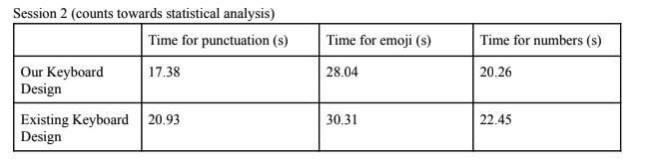

This table records the participant’s time to enter the three pieces of text (consisting of punctuation, emojis, and numbers) in seconds, respectively on our new keyboard design and the existing keyboard design. Each participant had a different 2 by 3 table recording their data (see Appendix for all 15 participants’ individual data).

To reiterate what we mentioned in the Methods section, we conducted a separate statistical test for the time of each piece of text (punctuation, emoji, and numbers) entered by the participants, since they were independent of each other. To better test these quantitative data, we incorporated the knowledge of hypothesis testing into our evaluation. We defined our Null Hypothesis (H0) as ‘There is *no difference* between the mean time to enter X on our new keyboard and the mean time to enter punctuation on the original keyboard’ and the Alternative Hypothesis (Ha) as ‘The mean time to enter X on our new keyboard is *faster than* the mean time to enter punctuation on the original keyboard’, where X can be either of: punctuation, emoji, and numbers.

For each of the 3 measures, we first drew a box plot to see the data distribution. The results are as follows.

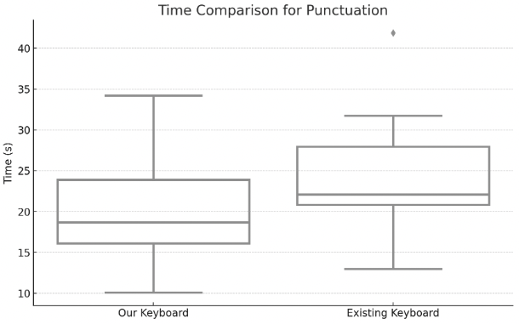

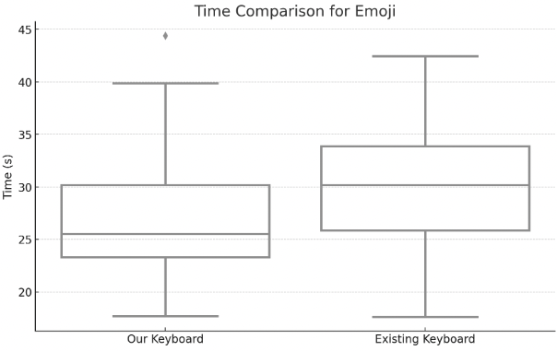

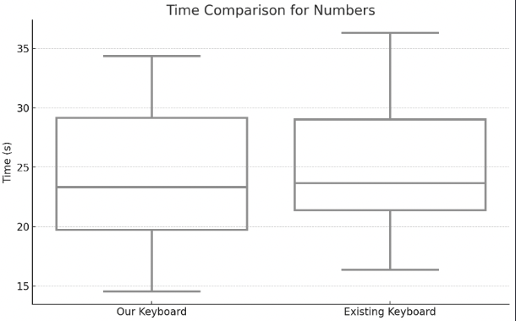

Based on the box plot, we can get some intuitive ideas about the results data. We can see that neither data follows normal distribution, since neither box is symmetrical with mean and median in the center. Most of the data does not follow normality and is right-skewed with few outliers. Furthermore, with only 15 participants in our study, it's not feasible to assert that our overall data exhibits normality. This limitation stems from the small sample size, which does not align with the Law of Large Numbers. Also, we noticed that our focus is to compare the time (seconds) the user performed on different keyboard designs, so this is a paired evaluation. Based on the information above, we used the Wilcoxon Single Rank Test for our statistical analysis. Based on the hypothesis definition, it's evident that we are dealing with a one-tailed paired test. This is because the alternative hypothesis is focused on assessing a 'faster' time (one-tailed), as opposed to a 'different' time (two-tailed).

We then calculated the Wilcoxon test using R and got t-values. We also transformed t-values into p-values to get a more readable result. Then we compared the t-value with 0.05 (95% confidence interval) to measure the statistical significance of our data.

For Dependent Variable 1: Test the Punctuation

**Null Hypothesis**: There is *no difference* between the mean time to enter punctuation on our new keyboard and the mean time to enter punctuation on the original keyboard.

**Alternative Hypothesis**: The mean time to enter punctuation on our new keyboard is *faster than* the mean time to enter punctuation on the original keyboard.

P-Value: 0.0056

T-value: -2.92

Analysis:

Participants were on average faster (t(14) = -2.92, p = 0.0056) with our newly designed keyboard (mean=20.01 seconds) than the original keyboard (mean=24.47 seconds) when entering punctuation.

The p-value is 0.0056, which is less than the typical alpha level of 0.05. Therefore, we reject the null hypothesis for the punctuation dependent variable. This suggests that there is a strong statistically significant difference in typing speed between the two keyboard designs for punctuation, favoring "Our Keyboard Design".

For Dependent Varaible 2: Test the emoji

**Null Hypothesis**: There is *no difference* between the mean time to enter emoji on our new keyboard and the mean time to enter emoji on the original keyboard.

**Alternative Hypothesis**: The mean time to enter emoji on our new keyboard is *faster than* the mean time to enter emoji on the original keyboard.

P-Value: 0.0285

T-value: -2.07

Analysis:

Participants were on average faster (t(14) = -2.07, p = 0.0285) with our newly designed keyboard (mean=27.74 seconds) than the original keyboard (mean=30.13 seconds) when entering emojis.

The p-value is 0.0285, which is less than the typical alpha level of 0.05. Therefore, we reject the null hypothesis for the emojis dependent variable. This suggests that there is a statistically significant difference in typing speed between the two keyboard designs for emoji, favoring "Our Keyboard Design".

For Dependent Variable 3: Test the Number

**Null Hypothesis**: There is *no difference* between the mean time to enter number on our new keyboard and the mean time to enter number on the original keyboard.

**Alternative Hypothesis**: The mean time to enter numbers on our new keyboard is *faster than* the mean time to enter numbers on the original keyboard.

P-value: 0.2610

T-value: -0.66

Analysis:

Participants were *not* on average faster (t(14)=-0.66, p=0.2610) with our newly designed keyboard (mean=24.13 seconds) than the original keyboard (mean=24.94 seconds) in the test number section.

The p-value is 0.2610, which is not less than the alpha level of 0.05. Therefore, we failed to reject the null hypothesis. This suggests that our keyboard design for numbers does not necessarily make typing numbers faster than the traditional keyboard.

**Discussion:**

(same as previous)

10.5 High-Fidelity Prototype and Quantitative Statistical Analysis

Our study aimed to evaluate a new keyboard design, focusing on its efficiency in entering punctuation, emojis, and numbers with one hand, as compared to a standard keyboard design. This evaluation was essential to determine if our design could meet specific user requirements, particularly User Requirement 5. Our findings offer insightful conclusions about our high-fidelity prototype, designed and tested using Figma.

One of the challenges we faced was the usability of Figma for creating a functional and interactive keyboard prototype. To mitigate this, we employed a two-pass session strategy, focusing our analysis on data from the second session. This approach helped us filter out initial adaptation and learning curves, ensuring the results reflected users' true proficiency with each keyboard design.

Our statistical analysis revealed that our keyboard design significantly improved typing speed for punctuation. This outcome aligns with our expectations, as we had specifically revised and improved the punctuation aspect of the design. In contrast, the number entry did not show a statistically significant improvement in speed. This result was anticipated since we did not modify the number functionality; we only shifted the layout without altering its core design.

The most intriguing outcome was observed with the emoji keyboard. Although we did not intentionally modify its functionality—merely shrinking and shifting the entire keyboard layout—our design yielded a significant improvement in typing speed. Several factors could explain this unexpected result based on our discussion:

1. Adaptation to One-Handed Typing: Participants might have become more accustomed to the one-handed typing approach, which could have facilitated quicker emoji entry, even without specific functional changes to the emoji keyboard.

2. Reduced Emoji Set: The shifted keyboard design featured only 24 emojis compared to the original 32. This reduction likely simplified the selection process, minimizing visibility issues and decision-making time for users when choosing the correct emoji.

3. Ergonomic Benefits: The keyboard shift might have unintentionally resulted in a more ergonomic layout for one-handed use, especially for emoji selection, contributing to the observed increase in typing speed.

**Conclusion**:

Our previous survey into one-handed text messaging on mobile devices provided foundational insights that set the stage for our subsequent research. Among the 27 participants, it was evident that one-handed typing is a prevalent method on smartphones. However, it came with its challenges: users found it less comfortable, more challenging, and slower than two-handed typing. This highlighted potential limitations in current smartphone keyboard designs and emphasized the practical importance of our research.

Building on this foundation, our detailed contextual inquiry further illuminated the differences of one-handed text messaging. We discovered that the existing keyboard layout often poses challenges, especially when users are multitasking. The challenges users face with current keyboard layouts, autocorrect features, and the act of switching between different keyboard modes have informed 6 specific user requirements. These requirements will be crucial in guiding the design of future mobile keyboards optimized for one-handed use.

Based on the specific requirements, we derived our initial design as the low-fidelity paper prototype. We also designed several design critiques and iteratively optimized our prototype. Our design mainly established and focused on the ‘squash’ and ‘scroll’ methods so users can comfortably reach all key elements with one hand. Our design also retains most of the traditional QWERTY keyboard layout, ensuring users face a minimum learning curve as well as solving main challenges in one-handed typing.

We conducted heuristic evaluation and simplified user testing to evaluate our prototype. Both heuristics evaluation and simplified user testing reveal nearly the same issues. Based on the result, we promise to say that there are nearly no severe usability issues with the core ideas but there are still some features that lack discoverability and visibility. Though all of our user requirements have some usability issues, we at least pass two-thirds of user requirements based on our discussion. We are going to fix those issues in our next iteration.

In the final step, we built our high-fidelity prototype and evaluated it with 15 participants. Based on the quantitative statistical analysis result, we can conclude that our new design for entering punctuation decreases the typing speed, which fits our expectations. For emoji and number typing, we can surprisingly see that users can still decrease typing speed by entering emojis, and this is probably based on our novel shifted keyboard design.

In conclusion, through the initial survey, contextual inquiries, low-fidelity paper prototype, interactive system evaluation, and high-fidelity prototype, we can build our novel keyboard design to increase one-handed typing efficiency. It not only provides insights and potential solutions into the current challenges users face but also guides as a robust foundation for future work. In the future, we are going to improve our high-fidelity prototype with more functionality, such as designing the number and emoji keyboard and creating the shifted keyboard for left-handed users. Besides, we are optimistic that future researchers and designers will leverage these findings, leading to innovations that cater to the evolving needs of one-handed mobile device users.

**F.1 Apparatus ScreenShots**:













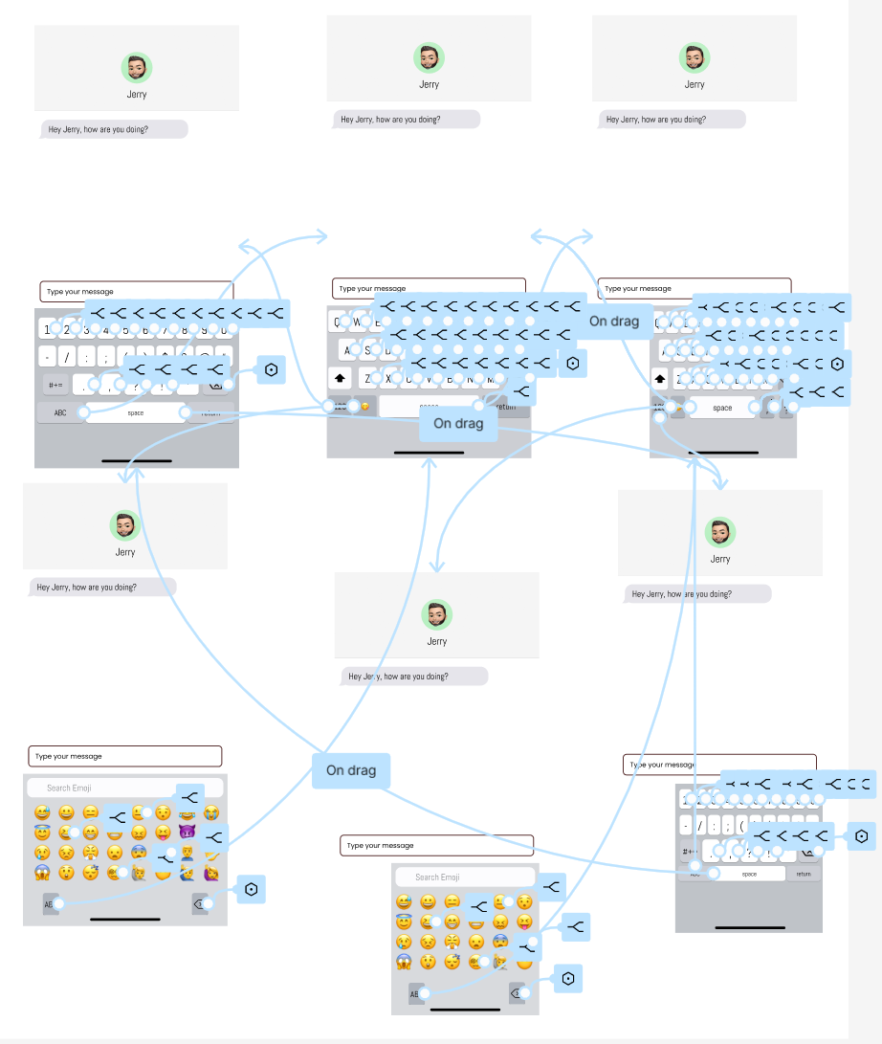=

**F.2. Anonymized and De-identified Participants Data**

| Participant | Age | Gender | Race | Employment status | Dominant hand | Phone brand | Multi-lingual | Disability |
| --- | --- | --- | --- | --- | --- | --- | --- | --- |
| 1 (Jerry) | 24 | Man | Asian | Employed half-time | Right | iPhone | Yes | No |
| 2 (Jerry) | 21 | Man | Asian | Student | Right | iPhone | Yes | No |
| 3 (Jerry) | 22 | Man | Asian | Student | Right | iPhone | Yes | No |
| 1 (Daniel) | 20 | Man | Indian | Student | Right | iPhone | Yes | No |
| 2 (Daniel) | 22 | Man | Asian | Student | Right | iPhone | Yes | No |
| 3 (Daniel) | 21 | Woman | Asian | Student | Right | iPhone | Yes | No |
| 1 (Isaac) | 22 | Man | Asian | Student | Right | iPhone | Yes | No |
| 2 (Isaac) | 21 | Man | Asian | Student | Right | iPhone | Yes | No |
| 3 (Isaac) | 22 | Man | Asian | Student | Right | iPhone | Yes | No |
| 1 (Franklin) | 27 | Man | Asian | Student | Right | iPhone | Yes | No |
| 2 (Franklin) | 33 | Man | Asian | Employed  Full-Time | Right | iPhone | Yes | No |
| 3 (Franklin) | 23 | Man | Asian | Student | Right | iPhone | Yes | No |
| 1 (Yichen) | 22 | Man | Asian | Student | Right | iPhone | Yes | No |
| 2 (Yichen) | 24 | Man | Asian | Student | Right | iPhone | Yes | No |
| 3 (Yichen) | 23 | Woman | Asian | Employed  Full-Time | Right | iPhone | Yes | No |

# 